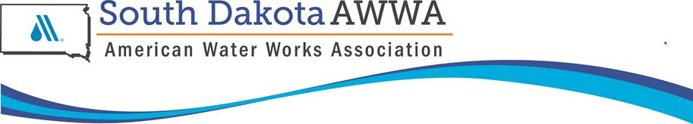

**SDAWWA Annual Business Meeting**

**Thursday, September 14, 2023**

**Holiday Inn-Spearfish SD**

**Call to Order at 4:53 pm by Haecherl**.

**Approval of Agenda-**The agenda had been placed on web site. Brian Hoellein moved to approve the agenda. Goodmanson seconded. Motion carried.

**Approval of 2022 Business Meeting Minutes-**The minutes had been placed on the web site. Goodmanson moved to approve the minutes. Dale seconded. Motion carried.

**Reports:**

**Treasurer’s Report-**Seton submitted the Treasurer’s Report. There is $6449 in surplus with the Section’s net worth at $144,844. There was discussion on the amount of money in savings and holding for the RMSO. This is Seton’s last meeting as Cotter and Kittay will be taking over the check book.

**Section Manager-**Kittay was not able to attend due to a family emergency.

**Director’s Report-**Honner reported on AWWA National. There was a recap of Water 2050 efforts and the next steps to be taken. Great feedback on town hall and water seminar. Several ideas were included in national plan. There was also general discussion on action against the New England Section.

**SDWWA Liaison Report-**Goodmanson reported on the SDWWA and their actions for the year. A joint meeting was held again on Tuesday between SDWWA, WEA and AWWA. Ted Lewis will be taking over this position.

**Chair Report-**Haecherl reported activities from the past year. There was general discussion on the RMSO that we held and the monthly meetings with Maggie V.

Thorson moved to approve the reports. Erickson seconded. Motion passed

**Council and Committee Business:**

**Administrative and Policy-**Skillingstad reported. Updates to the by-laws is taking place to reflect descriptions of director and secretary roles. Board can be up to 15 members. The membership goal for this year is 2% (182 to 197). The Section is currently at 182.

**Technical and Education-**Kloos reported. RCAP training was just completed in Sioux Falls with the Rapid City workshop coming up next week.

**Public Affairs-**Austin Hoellein reported. The mulligans at the SDWWA CC Golf Tourney netted $840 while the YP bean bag tourney brought in $610.

**Water Industry-**Newman reported. This is Newman’s last year in this role. He discussed the DC Fly-In and the legislative luncheon with Mark Mayer-better attendance is desired for next year. Hot topics include polluter pays/PFAS, source water protection, and cyber security.

**YP Committee-**Diaz reported. She discussed the summit in Sacrament in March, the social events hosted by YP, and updates on the student sections-SDSU.

Motion by Goodmanson to accept the reports. Seconded by Honner. Motion passed.

**National Representative-**Mary Gugliuzza was the national AWWA rep. She spoke about the National Farm Bill that is up for renewal and includes source water protection, PFAS, Water 2050, and membership numbers. North Dakota has 198 members-Can SD beat them.

**Election for 2023-24 Board-**The nominating committee proposed the following slate of officers:

* + Chair: Matt Erickson
  + Past Chair: Ben Haecherl
  + Chair Elect: Kevin Newman
  + Secretary/Treasurer: Sam Cotter
  + Public Affairs Council Chair: Austin Hoellein
  + Technical and Education Council Chair: Rachel Kloos
* Water Utility Council Chair: Kyle Goodmanson
* Administrative and Policy Council Chair: Casey Skillingstad
  + Young Professionals Chair: Kyla Diaz
  + Director: Brian Hoellein
  + Other Positions
    - Section Manager: Rob Kittay
    - SDWWA Liaison: Ted Lewis

Nominations from the floor were asked for. There were none. ??? moved to accept the slate of nominees. ??? seconded. Motion passed.

**Adjournment-**Brian Hoelleinmoved to adjourn. Goodmanson seconded. Motion passed. Meeting was adjourned at 6:15 pm.

Respectfully submitted by Rob Kittay